

**2024 Water, Sanitary Sewer and Storm Sewer Rates**

Your City of Wauwatosa water bill consists of three parts: water, sanitary sewer, and storm water charges. This notice provides information related to the water, sanitary and storm water portion of the bill.

**Local rates will not increase in 2024**

The Milwaukee Metropolitan Sewerage District (MMSD) is increasing their rates approximately 7% which is passed onto the Wauwatosa customer in the sanitary portion of their bill.

Given this increase, and the overall 15.0% increase in the entire bill in 2023, the City has decided to not increase any local rates. This means water, storm water, and local sanitary rates will not increase in 2024.

**An average bill for a Wauwatosa Resident in 2024**

If you look at your utility bill, you’ll see that water and sewer usage is shown in ccf (hundred cubic feet). An average residential property (single-family household) typically uses 20 ccf per quarter. We anticipate that the average residential total quarterly bill - including charges for water, sanitary and storm sewer - will increase from $294 in 2023 to $298, approximately 1.0% due to the MMSD increase effective this bill.

**The Past: What we’ve already replaced**

From 2011 to 2022, we repaired and/or replaced 62 miles of sanitary sewer and 24 miles of storm sewer. Improvements replace end-of-life sewer mains, expand system capacity, and alleviate flooding during storms due to undersized pipes.

From 2011 to 2022, we replaced or relined approximately 17 miles of water mains. Given the age of our water mains, we are planning for an ongoing replacement program. Between 2020 and 2023, we have upgraded 3 of our 4 pump houses’ pumping equipment. With the fourth pump house pumping equipment upgrade projected to be finished spring 2024.

**Understanding the winter quarter average**

The sewer usage portion of residential (1-2 family) bill is based on the previous year’s winter quarter. For example, 2024 sewer usages will be based off 2023 winter quarter water usage. The reasoning behind this method is that not all of the water used during the summer will be going down the drain. Some water will be absorbed or drain into the storm sewer during watering of the grass/gardens/flowers, washing of cars, going into swimming pools, etc.

If there was a water leak during the winter and you have since fixed the leak or now have a change in occupancy to fewer people in the household, please contact our office at [water@wauwatosa.net](mailto:water@wauwatosa.net). For new customers who do not have a prior winter quarter, default usage is used: 12 CCF for single family & 20 for duplex. If your water usage is less than the default values, please contact our office: [water@wauwatosa.net](mailto:water@wauwatosa.net).

**Monitor your water usage and get leak alerts**

One way you can monitor your water usage is to sign up for Eye on Water to receive text and email alerts if a leak is detected in your account (24 hours of continuous water usage). Make sure to check on leaks before it leads to a costly bill. More information at www.wauwatosa.net/water.

**How does the Wauwatosa Utility bill compare?**

There isn’t a single database for water, sanitary, and stormwater but the following can help put the utility bill into perspective:

City Utility bill compared to other monthly costs

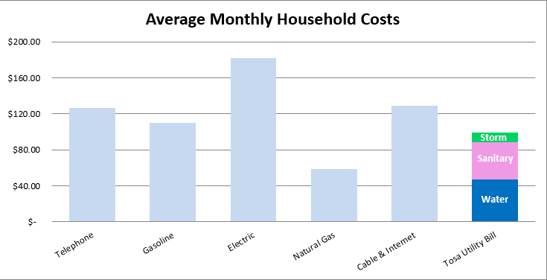

City water bill compared to Statewide and County averages

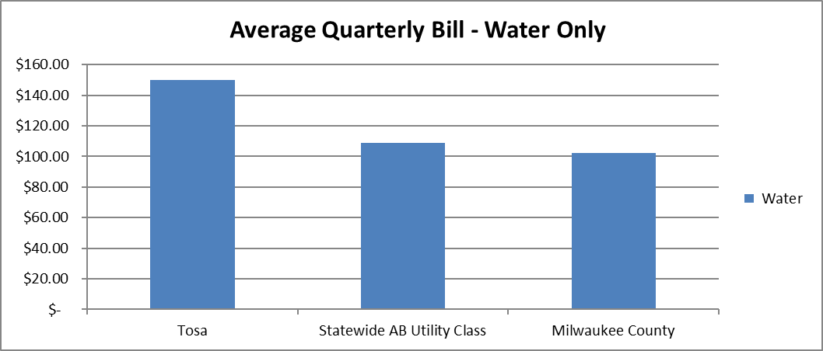

If you have any questions or would like more information, visit our website at wauwatosa.net/water or contact the Wauwatosa Water Utility at 414-479-8963.