Role of social workER  Social work is often known as the “helping profession.” The primary mission of social work is to enhance human well-being and help meet the basic and complex needs of all people.  Social work values include serving people in need, addressing social problems, promoting social justice, being mindful of cultural and ethnic diversity, recognizing the importance of human relationships, and advocating for societal changes.  For the City of Wauwatosa, the Social Worker will respond to calls and cases that are referred to them in order to determine if additional assistance or services can be provided or offered to the residents in need. This is a voluntary service and residents cannot be required or mandated to meet with the Social Worker.  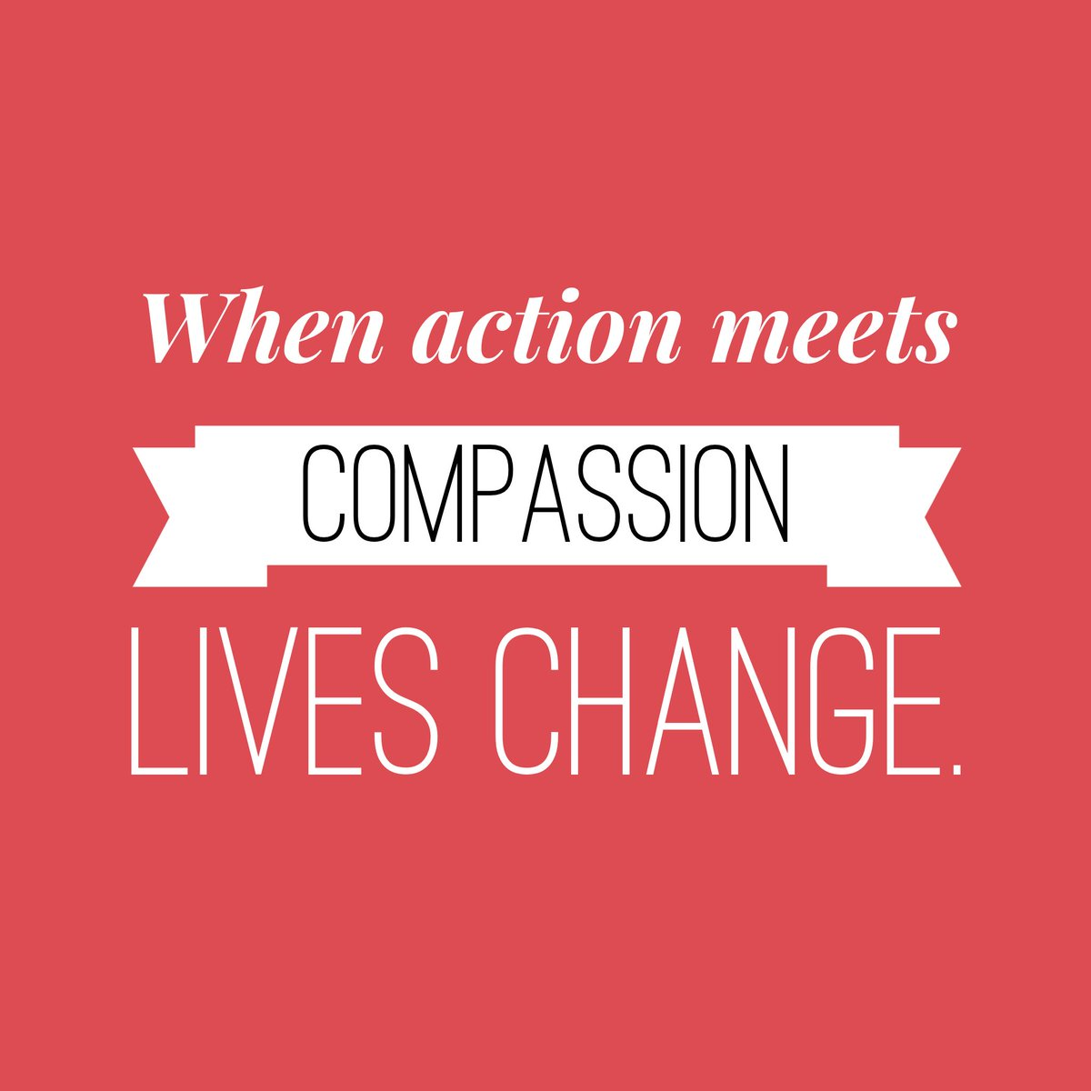 | 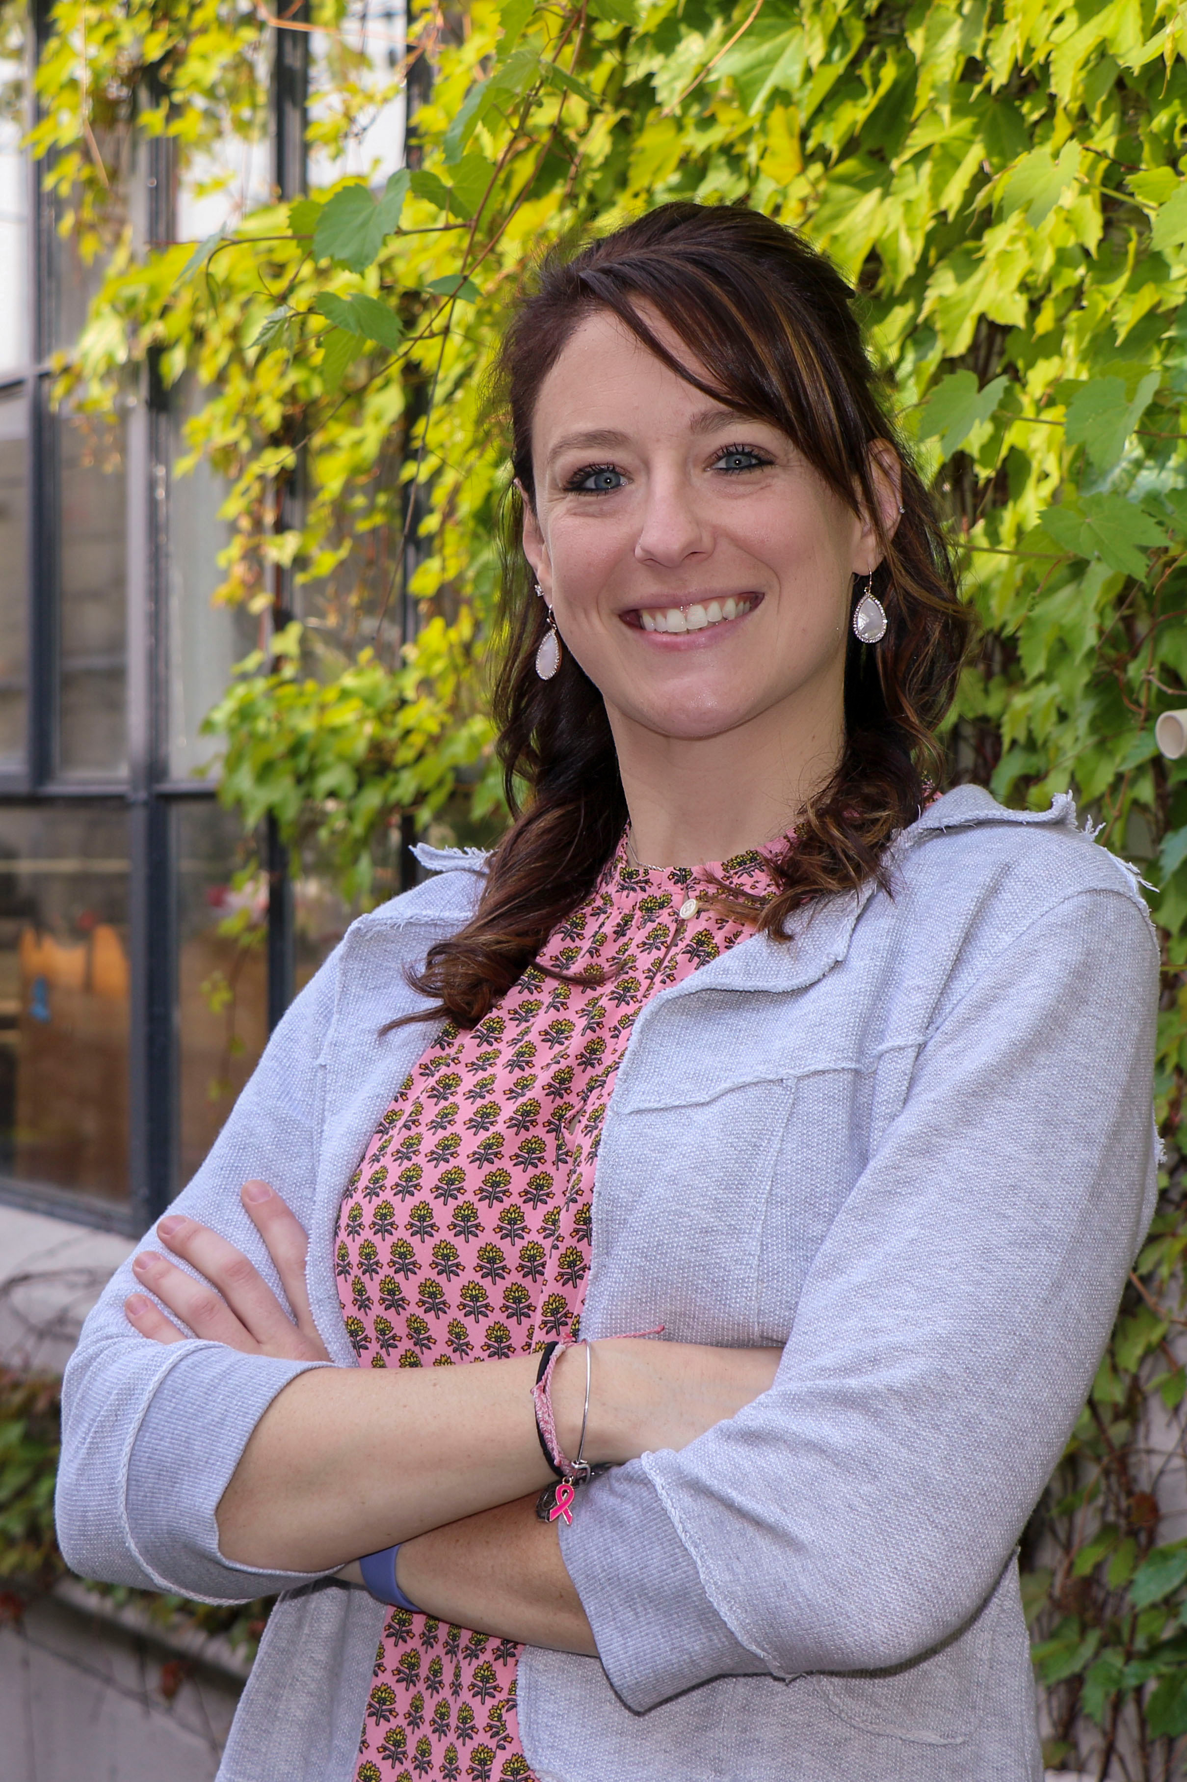  CONTACT INFORMATION  - Kendall Wolter, APSW  PRIMARY OFFICE LOCATION:  HEALTH DEPT.  CITY HALL  7725 W. NORTH AVE  WAUWATOSA, WI 53213  PHONE:  414-479-3595 (OFFICE)  414-333-3719 (CELL)  414-471-8483 (FAX)  EMAIL:  SOCIALWORK@WAUWATOSA.NET | City of wauwatosa  Social Work Community Resource  fire, health, & police Response    Social Worker:  Kendall Wolter, APSW
INTRO  In April 2022, the City of Wauwatosa hired a full time Social Worker to assist Wauwatosa residents with access to community service and resource needs, primarily in response to increased stress as a result of the COVID-19 pandemic. The Social Worker works collaboratively with the following city departments: Fire, Health, and Police. Referrals can be made to the Social Worker by each of those departments, as well as by community members. The Social Worker can be contacted directly for assistance, or community members can contact one of the previously mentioned city departments to get connected with the Social Worker. The Social Worker is able to meet with individuals in person or via phone to assess needs, refer to services or resources, and maintain follow-up case management contact with residents as appropriate. | focus areas  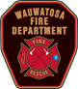  FIRE DEPARTMENT  - Substance use  - Aging  - Home safety    HEALTH DEPARTMENT  - Health hazards  - Basic needs  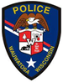  POLICE DEPARTMENT  - Mental health  - Domestic violence  referrals  Referrals can be emailed to socialwork@wauwatosa.net for follow-up. The following information should be included in all referrals:  Name(s) of resident(s) requiring assistance  Resident address  Resident phone number  Reason(s) for referral  Name/relationship of person submitting referral | rESOURCES  A Milwaukee County Resource Guide is regularly updated and maintained by the Social Worker. The guide includes commonly used services for Domestic Violence, Reporting Abuse, Aging Needs, Substance Use, Basic Needs, Education, Legal Needs, Mental Health, and Housing Needs. The Social Worker is also able to research additional situation-specific options and services not mentioned above.  If you need assistance locating a service or resource for a particular situation, or want additional education about a specific topic, please contact the Social Worker.  

